**Uncertainty perceptions and evaluation among CA and it’s alternatives:**

In every section, we have presented 10 examples of circles with different percentages of uncertainty/CA for user perception. Then we have added a questionnaire section with five circles one after another and the task is defined as to determine the uncertainty based on prior perception for each circle and write the corresponding answer in percentage (x%) afterwards.

**Ca** Evaluation section**:**

**Examples:**  
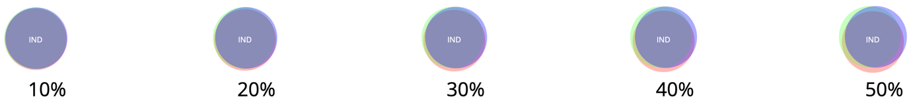

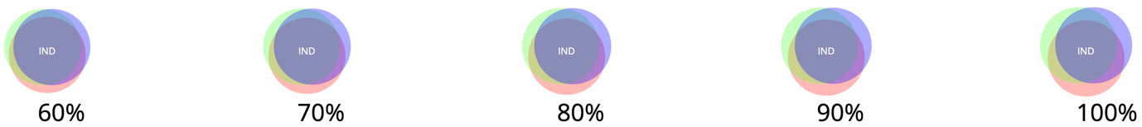

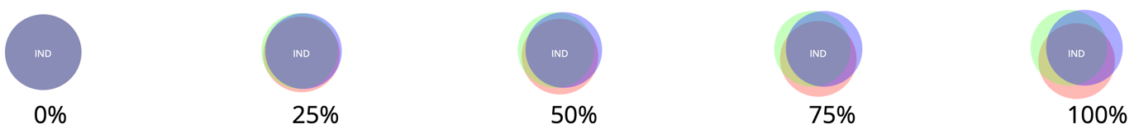

**Questionnaire:**

Q1. Estimate the uncertainty for the following circle in the range 10% to 100%

Answer:

Q2. Estimate the uncertainty for the following circle in the range 10% to 100%

Answer:

Q3. Estimate the uncertainty for the following circle in the range 10% to 100%

Answer:

Q4. Estimate the uncertainty for the following circle in the range 10% to 100%

Answer:

Q5. Estimate the uncertainty for the following circle in the range 10% to 100%

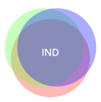

Answer:

**ca-static** Evaluation section:

**Examples:**

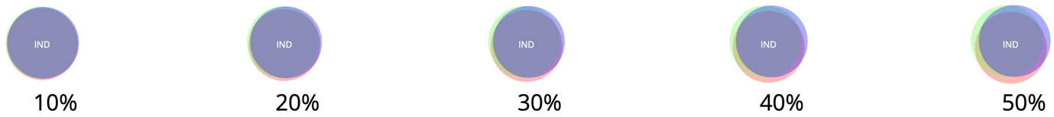

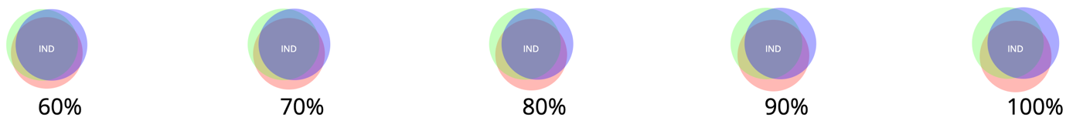

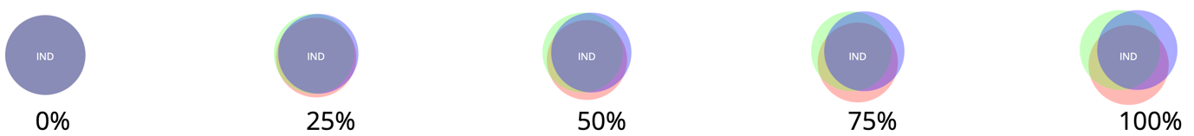

**Questionnaire:**

Q1. Estimate the uncertainty for the following circle in the range 10% to 100%

Answer:

Q2. Estimate the uncertainty for the following circle in the range 10% to 100%

Answer:

Q3. Estimate the uncertainty for the following circle in the range 10% to 100%

Answer:

Q4. Estimate the uncertainty for the following circle in the range 10% to 100%

Answer:

Q5. Estimate the uncertainty for the following circle in the range 10% to 100%

Answer:

**Blur** evaluation section**:**

**Examples:**

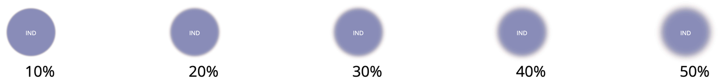  
  
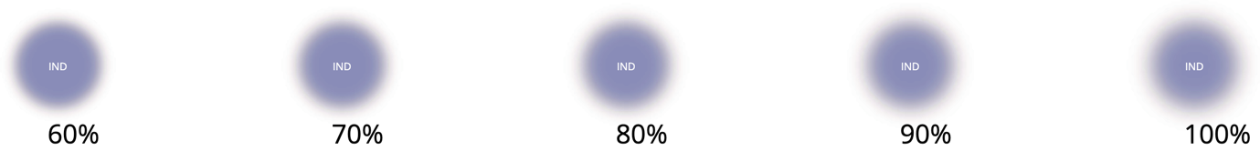

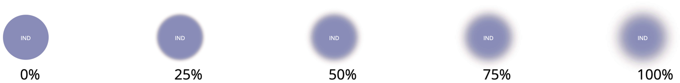

**Questionnaire**:

Q1. Estimate the uncertainty for the following circle in the range 10% to 100%

Answer:

Q2. Estimate the uncertainty for the following circle in the range 10% to 100%

Answer:

Q3. Estimate the uncertainty for the following circle in the range 10% to 100%

Answer:

Q4. Estimate the uncertainty for the following circle in the range 10% to 100%

Answer:

Q5. Estimate the uncertainty for the following circle in the range 10% to 100%

Answer:

**Noise** evaluation section:

**Examples:**

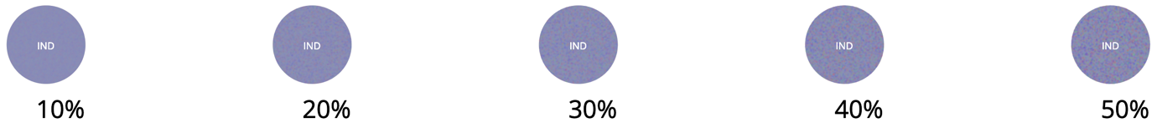

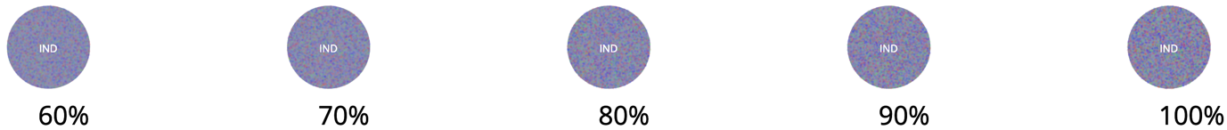

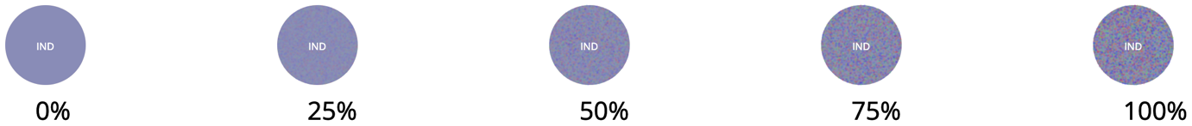

**Questionnaire:**

Q1. Estimate the uncertainty for the following circle in the range 10% to 100%



Answer:

Q2. Estimate the uncertainty for the following circle in the range 10% to 100%



Answer:

Q3. Estimate the uncertainty for the following circle in the range 10% to 100%



Answer:

Q4. Estimate the uncertainty for the following circle in the range 10% to 100%



Answer:

Q5. Estimate the uncertainty for the following circle in the range 10% to 100%



Answer: